Self Development & Hobbies

How to Not Always Be Working: A Toolkit for Creativity and Radical Self-Care

[Marlee Grace](https://bookshop.org/contributors/marlee-grace) (Author)

[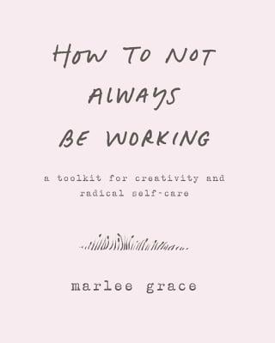](https://images-production.bookshop.org/spree/images/attachments/5938154/original/9780062803672.jpg?1588298162)

Description

This guide book is filled with practical advice to help you curb your obsessions and build boundaries between your work, your job, and your life.

In her workshops on healing and creative process, Marlee Grace helps people acknowledge their blocks and address them by setting distinct parameters that change their behavior. Now, she brings her methods and ideas to the wider world, offering all of us concrete ways to break free from our devices and focus on what's really important--our own aliveness.

Part workbook, part advice manual, part love letter, How to Not Always Be Working ventures into the space where phone meets life, helping readers to define their work--what they do out of sense of purpose; their job--what they do to make money; and their breaks--what they do to recharge, and to feel connected to themselves and the people who matter to them. Grace addresses complex issues such as what to do if your work and your job are connected, provides insights to help you figure out how much is too much, and offers suggestions for making the best use of your time.

Essential for everyone who feels overwhelmed and anxious about our hyper-connected world--whether you're a corporate lawyer, a student, a sales person, or a yoga instructor--How to Not Always Be Working includes practical suggestions and thoughtful musings that prompt you to honestly examine your behavior--how you burn yourself out and why you're doing it. A creative manifesto for living better, it shows you how to carve sacred space in your life.

From business anecdotes about fulfilling orders to more personal stories about Grace's recovery from divorce and addiction, this book is full of wisdom and resilience, with plenty of discussion about ritual and routine as ways to create effective and positive creative life change.

### Product Details

Price

~~$16.99~~  **$15.63**

Publisher

Morrow Gift

Publish Date

October 23, 2018

Pages

112

Dimensions

4.88 X 0.5 X 6.0 inches | 0.4 pounds

Language

English

Type

Paperback

About the Author

Marlee Grace is a dancer and writer whose work focuses on the self, devotion, ritual, creativity, and art making. Her practice is rooted in improvisation as a compositional form that takes shape in movement videos, books, quilting, online courses, and hosting artists. Marlee's Instagram dance project Personal Practice has been featured in the New York Times, Dance Magazine, Vanity Fair, The Huffington Post, and more. You can find her zines, things she makes, artists she hosts, and more at marleegrace.space/home.

How Not to Kill Yourself: A Survival Guide for Imaginative Pessimists

[Set Sytes](https://bookshop.org/contributors/set-sytes) (Author)  [Faith G. Harper](https://bookshop.org/contributors/faith-g-harper-72e37625-4478-4d52-8259-f4c332ccb86b) (Contribution by)

[](https://images-production.bookshop.org/spree/images/attachments/3920446/original/9781621061977.jpg?1617745395)

Description

A highly imaginative and relatable guide for anyone who needs the reassurance that suicide is NEVER worth it.

Are you inclined to escape the crumminess of everyday life into fantasy worlds? Are you smart and imaginative in a way that isn't really suited to your surroundings? Are you definitely misunderstood, likely angry, and almost certainly depressed? Set Sytes, hailing from the UK, would prefer you stay alive and sort things out rather than the alternative, thanks. He figures there are better opportunities for you out there and lays it all out in a way that's compelling, funny, sharp, and useful. This zine turned book (please don't call it a self-help guide, asks the author) is ultimately about how to be a person in the world. It can be done non-miserably, we promise.

### Product Details

Price

~~$9.95~~  **$9.15**

Publisher

Microcosm Publishing

Publish Date

March 13, 2018

Pages

128

Dimensions

5.2 X 0.4 X 6.6 inches | 0.3 pounds

Language

English

Type

Paperback

About the Author

Set Sytes was born in the misty, Arthurian woods of England and was raised by bears. He grew up learning how to do and be many things at the same time, including slaying monsters, rescuing damsels in distress (who turned out to be neither in distress nor, in fact, damsels), and commanding great armies (the strategy involved inevitably being everybody charge at the enemy). As the Real World struck with a calamitous clang, Set was found wandering around in the desolate aftermath, completely uncertain about what was now expected of him. He faffed and stumbled around for an embarrassingly long time (sometimes failing quite spectacularly) and then finally turned his hand to the only thing he remembered being any good at as a kid: writing. He was relieved to break the curse of never having finished anything in his life, when he finished his first novel. Which was okay-ish. Set has since authored many stories of darkness and weirdness and flights of fancy, including the sci-fi/fantasy/western novel WULF, the YA pirate fantasy India Bones and the Ship of the Dead, the thoroughly twisted dystopian thriller Moral Zero, and the fantasy/horror short story collections of Faces in the Dark and Born to be Weird. Set requests politely that you don't put onions anywhere near his food.

How to Not Be a Dick

[Sammuel E Harper](https://bookshop.org/contributors/sammuel-e-harper) (Author)  [Faith Acs Acn Harper Phd Lpc-S](https://bookshop.org/contributors/faith-acs-acn-harper-phd-lpc-s) (Author)

[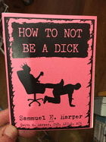](https://images-production.bookshop.org/spree/images/attachments/12550693/original/9781621069591.jpg?1608076501)

Description

Imagine being the kid of a trauma therapist and bestselling mental health author. The pressure's on, right? Dr. Faith's son Samm rises to the challenge admirably, sharing his young life's worth of valuable lessons in perhaps the most important life skill that there is: non-jerkitude. In a day and age when being an absolute dick to the people around you is rewarded, it's easy to forget that kindness--or even just non-mean-ness--is not only totally possible, it might even make your life better. Appropriate for adults or teens, this is a valuable little life manual on the basics.

### Product Details

Price

~~$3.00~~  **$2.76**

Publisher

Microcosm

Publish Date

December 03, 2018

Pages

28

Language

English

Type

Paperback

About the Author

Faith G. Harper, PhD, LPC-S, ACS, ACN is a bad-ass, funny lady with a PhD. She's a licensed professional counselor, board supervisor, certified sexologist, and applied clinical nutritionist with a private practice and consulting business in San Antonio, TX. She has been an adjunct professor and a TEDx presenter, and proudly identifies as a woman of color and uppity intersectional feminist. She is the author of the book Unf*ck Your Brain and many other popular zines and books on subjects such as anxiety, depression, and grief. She is available as a public speaker and for corporate and clinical trainings.

Fuck Happiness: How Women Are Ditching the Cult of Positivity and Choosing Radical Joy

[Ariel Gore](https://bookshop.org/contributors/ariel-gore-ddab0c5b-ad38-4320-9c83-28348279e4c5) (Author)

[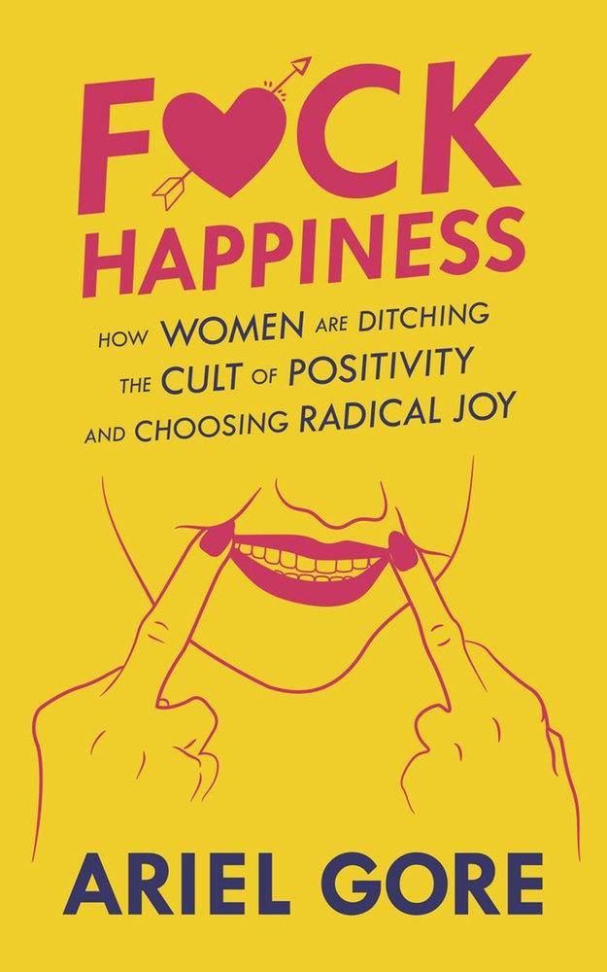](https://images-production.bookshop.org/spree/images/attachments/11900829/original/9781621069508.jpg?1587928790)

Description

Happiness is big business. Books, consultants, psychologists, organizations, and even governments tout happiness secrets that are backed by scientific findings. The problem is that all of this science is done by and for cis white men. And some of the most vocal of these happiness experts were announcing that women could become happier by espousing "traditional" values and eschewing feminism. Skeptical of this hypothesis, Ariel Gore took a deep dive into the optimism industrial complex, reading the history, combing the research, attending the conferences, interviewing the thought leaders, and exploring her own and her friends' personal experiences and desires. Fuck Happiness is a nuanced, thoughtful examination of what happiness means and to whom, how it's played a role in defining modern gender roles and power structures, and how we can all have a more empowered relationship with the pursuit of joy in our lives.

### Product Details

Price

~~$16.95~~  **$15.59**

Publisher

Microcosm Publishing

Publish Date

May 12, 2020

Pages

224

Dimensions

5.0 X 7.9 X 0.8 inches | 0.5 pounds

Language

English

Type

Paperback

About the Author

Ariel Gore is an award-winning editor, memoirist, journalist, fiction writer, and former publisher of Hip Mama.

Quit Your Day Job: Build the DIY Project, Life, and Business of Your Dreams

[Eleanor C. Whitney](https://bookshop.org/contributors/eleanor-c-whitney) (Author)

[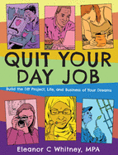](https://images-production.bookshop.org/spree/images/attachments/14065975/original/9781621061151.jpg?1617136362)

Description

A practical field guide for creative people with great ideas for independent projects who want to achieve success and sustainability. Drawing on her years of experience helping people succeed with do-it-yourself projects based in independent publishing, music, food, art, craft, activism, and community work, Eleanor Whitney empowers you to clarify your vision, get organized, set goals, create a plan, raise funds, market, and manage your do-it-yourself project. The book is full of real-life inspiration and creative business advice from successful, independent businesses owners and creative people with projects that began in the do-it-yourself spirit.

### Product Details

Price

~~$13.95~~  **$12.83**

Publisher

Microcosm Publishing

Publish Date

September 08, 2020

Pages

128

Dimensions

5.3 X 6.6 X 0.3 inches | 0.3 pounds

Language

English

Type

Paperback

About the Author

Eleanor C. Whitney is a feminist writer, musician, and editor living in Brooklyn. She has built community and content strategy for startups and arts organizations including Axiom, Managed by Q, Dev Bootcamp, Shapeways, and the Brooklyn Museum. Her first book, Grow, is a practical field guide for managing a creative business. She's currently working on her next book, Riot Woman, a collection of feminist essays, and is the host of a podcast of the same name. She loves to punch out her writer's block at her local boxing gym.

The Complete Book of Chess Strategy: Grandmaster Techniques from A to Z

[Jeremy Silman](https://bookshop.org/contributors/jeremy-silman) (Author)

[](https://images-production.bookshop.org/spree/images/attachments/7601499/original/9781890085018.jpg?1588150244)

Description

This comprehensive guide, in dictionary form, makes all aspects of chess strategy quick, easy, and painlessly accessible to players of all degrees of strength. Each strategic concept is listed alphabetically and followed by a clear, easy-to-absorb explanation accompanied by examples of how this strategy is used in practice.

### Product Details

Price

~~$18.95~~  **$17.43**

Publisher

Siles Press

Publish Date

July 01, 1998

Pages

360

Dimensions

6.05 X 0.93 X 8.97 inches | 1.36 pounds

Language

English

Type

Paperback

About the Author

International Master Jeremy Silman is co-author (with Yasser Seirawan) of Microsoft Press's series of chess books, and author of several openings books. International Master John Donaldson is an Associate Editor of the acclaimed magazine Inside Chess (Seattle). He is author of several books, including theoretical opening works and painstakingly researched player biographies. He plays regularly and successfully in North American tournaments.

Guitar for Beginners: How You Can Confidently Play Guitar In 10 Days, Even If You've Never Played a Single Chord In Your Life

[Lance Voight](https://bookshop.org/contributors/lance-voight) (Author)

[](https://images-production.bookshop.org/spree/images/attachments/542948/original/9781916147836.jpg?1588622090)

Description

Want to learn to play the guitar FAST? - without spending weeks learning boring musical theory?

Now thanks to a series of tips, tricks and hacks you can!

You can even play real songs on day 1!

Perfect for an absolute beginner! Using this book, you'll feel confident playing all over the fretboard in only 10 days!

No experience, or expensive hardware needed!

Guitar for Beginners contains:

1.The only 3 chords you need to know to play basic songs (if you just learned these 3, you can play thousands of songs!)

2.A super simple way to tune your guitar by ear (even a complete novice can do this)

3.The only 3 chords you need to know to play basic songs so you can play from day 1!

4.2 more chords that open up a whole catalogue of music from rock to blues to modern pop!

5.A whole bunch of classic songs that will get you up to speed fast

6.Handy pro tips for strumming, chord changes and building up your playing speed

7.Bonus video and tab resources for popular songs

and much much more...

Even if you have zero musical experience, or you think that you just can't play an instrument - this book will prove you wrong

Or, if you know someone who's going to receive a guitar as a holiday gift - this is a perfect companion book to get them up to speed quickly!

### Product Details

Price

~~$14.57~~  **$13.40**

Publisher

Financial Freedom Publishing

Publish Date

June 27, 2019

Pages

90

Dimensions

5.0 X 0.19 X 8.0 inches | 0.21 pounds

Language

English

Type

Paperback

On Writing: A Memoir of the Craft

[Stephen King](https://bookshop.org/contributors/stephen-king) (Author)

[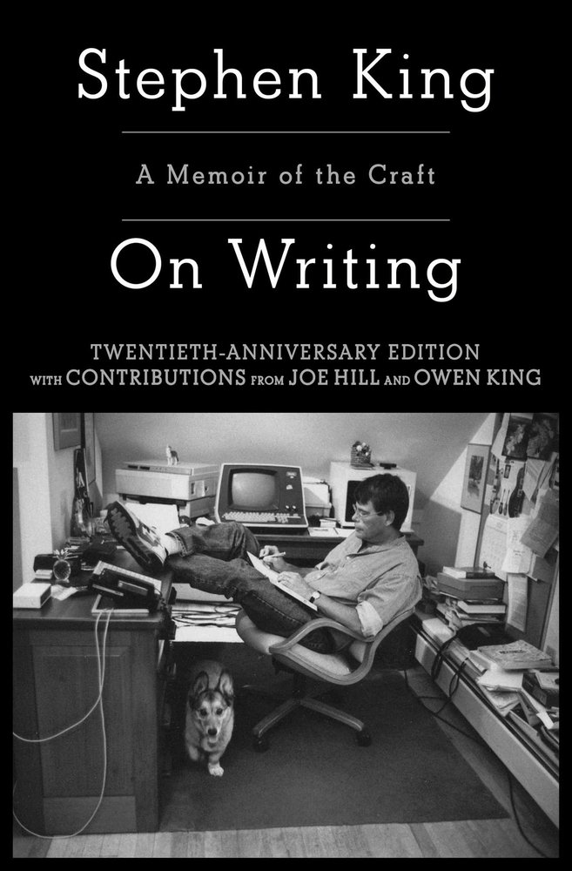](https://images-production.bookshop.org/spree/images/attachments/12658606/original/9781982159375.jpg?1590061475)

Description

Twentieth Anniversary Edition with Contributions from Joe Hill and Owen King

ONE OF TIME MAGAZINE'S TOP 100 NONFICTION BOOKS OF ALL TIME

Immensely helpful and illuminating to any aspiring writer, this special edition of Stephen King's critically lauded, million-copy bestseller shares the experiences, habits, and convictions that have shaped him and his work.

"Long live the King" hailed Entertainment Weekly upon publication of Stephen King's On Writing. Part memoir, part master class by one of the bestselling authors of all time, this superb volume is a revealing and practical view of the writer's craft, comprising the basic tools of the trade every writer must have. King's advice is grounded in his vivid memories from childhood through his emergence as a writer, from his struggling early career to his widely reported, near-fatal accident in 1999--and how the inextricable link between writing and living spurred his recovery. Brilliantly structured, friendly and inspiring, On Writing will empower and entertain everyone who reads it--fans, writers, and anyone who loves a great story well told.

### Product Details

Price

~~$18.00~~  **$16.56**

Publisher

Scribner Book Company

Publish Date

June 02, 2020

Pages

320

Dimensions

5.4 X 8.3 X 0.9 inches | 0.7 pounds

Language

English

Type

Paperback

About the Author

Stephen King is the author of more than sixty books, all of them worldwide bestsellers. His recent work includes If It Bleeds, The Institute, Elevation, The Outsider, Sleeping Beauties (cowritten with his son Owen King), and the Bill Hodges trilogy: End of Watch, Finders Keepers, and Mr. Mercedes (an Edgar Award winner for Best Novel and a television series streaming on Peacock). His novel 11/22/63 was named a top ten book of 2011 by The New York Times Book Review and won the Los Angeles Times Book Prize for Mystery/Thriller. His epic works The Dark Tower, It, Pet Sematary, and Doctor Sleep are the basis for major motion pictures, with It now the highest-grossing horror film of all time. He is the recipient of the 2020 Audio Publishers Association Lifetime Achievement Award, the 2018 PEN America Literary Service Award, the 2014 National Medal of Arts, and the 2003 National Book Foundation Medal for Distinguished Contribution to American Letters. He lives in Bangor, Maine, with his wife, novelist Tabitha King.

The Martha Manual: How to Do (Almost) Everything

[Martha Stewart](https://bookshop.org/contributors/martha-stewart) (Author)

[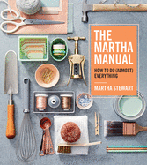](https://images-production.bookshop.org/spree/images/attachments/5347871/original/9781328927323.jpg?1593585918)

Description

Essential life skills from America's most trusted lifestyle expert--together in one beautiful and practical handbook, with hundreds of ideas, instructions, and inspirations

Martha Stewart is America's go-to source for the best answers to nearly every question. As an authority on the many worlds upon which she's built her domestic empire, she can advise on everything from creating a cutting garden and setting the table to playing classic lawn games or building a campfire. Whether it's organizing, celebrating, cleaning, decorating, or any number of other life skills, these are the time-tested, Martha-approved strategies for frequent challenges and basic how-to knowledge that everyone should have at the ready. Also included are plenty of solutions for the not-so-common conundrums, such as how to transport a decorated cake, bathe a cat, or fold an American flag. With hundreds of expert tips and useful insights in an easy-to-follow format, this is the manual you need to learn how to do everything--the Martha way.

### Product Details

Price

~~$35.00~~  **$32.20**

Publisher

Houghton Mifflin

Publish Date

January 01, 2019

Pages

400

Dimensions

8.3 X 1.4 X 9.0 inches | 3.4 pounds

Language

English

Type

Hardcover

About the Author

MARTHA STEWART is America's most trusted lifestyle expert and teacher, and the author of more than 90 books on cooking, entertaining, crafts, homekeeping, gardening, weddings, and decorating.

The Midwest Native Plant Primer: 225 Plants for an Earth-Friendly Garden

[Alan Branhagen](https://bookshop.org/contributors/alan-branhagen) (Author)

[](https://images-production.bookshop.org/spree/images/attachments/1945032/original/9781604699920.jpg?1601570826)

Description

Bring your garden to life--and life to your garden

Do you want a garden that makes a real difference? Choose plants native to our Midwest region. The rewards will benefit you, your yard, and the environment--from reducing maintenance tasks to attracting earth-friendly pollinators such as native birds, butterflies, and bees. Native plant expert Alan Branhagen makes adding these superstar plants easier than ever before, with proven advice that every home gardener can follow. This incomparable sourcebook includes 225 recommended native ferns, grasses, wildflowers, perennials, vines, shrubs, and trees. It's everything you need to know to create a beautiful and beneficial garden.

This must-have handbook is for gardeners in Arkansas, Illinois, Indiana, Iowa, Kansas, Michigan, Minnesota, Missouri, Nebraska, North Dakota, Ohio, South Dakota, and Wisconsin.

### Product Details

Price

~~$24.95~~  **$22.95**

Publisher

Timber Press (OR)

Publish Date

July 21, 2020

Pages

256

Dimensions

7.9 X 8.9 X 0.6 inches | 1.45 pounds

Language

English

Type

Paperback

About the Author

Naturalist and plantsman Alan Branhagen is director of operations at the Minnesota Landscape Arboretum and former director of horticulture at Powell Gardens, Kansas City's botanical garden. He specializes in botany, butterflies, birds, and garden design.